Advanced SQL Exercises for Online Retail Store

**Exercise 1: Ranking and Window Functions**

Goal: Use ROW_NUMBER(), RANK(), DENSE_RANK(), OVER(), and PARTITION BY.

Scenario:

Find the top 3 most expensive products in each category using different ranking functions.

Steps:

1. Use ROW_NUMBER() to assign a unique rank within each category.

2. Use RANK() and DENSE_RANK() to compare how ties are handled.

3. Use PARTITION BY Category and ORDER BY Price DESC

Using sample data from Index.sql file

ROW_NUMBER()

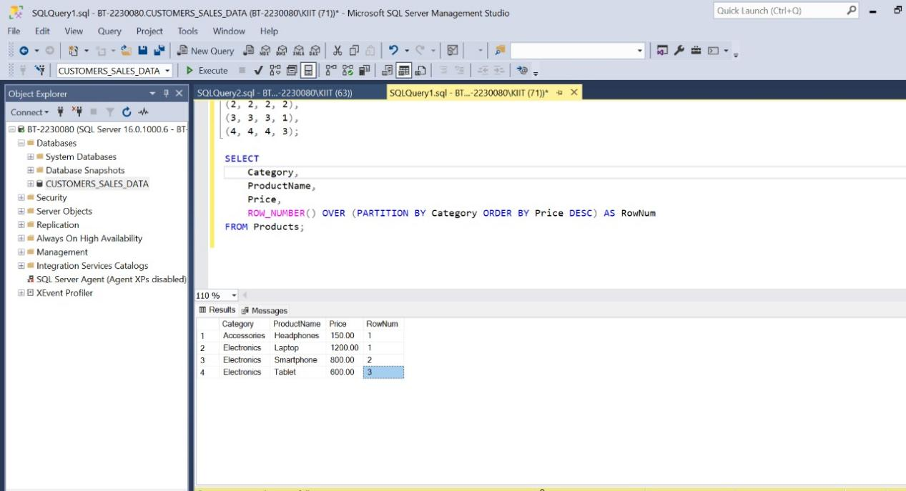

RANK()

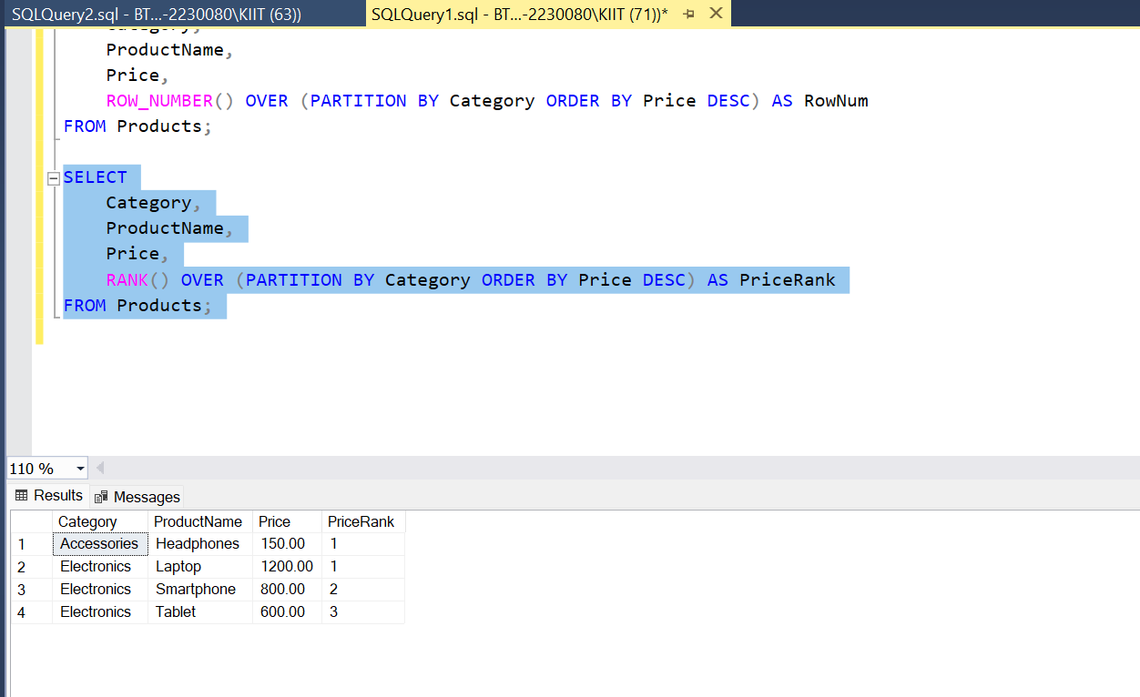

DENSE

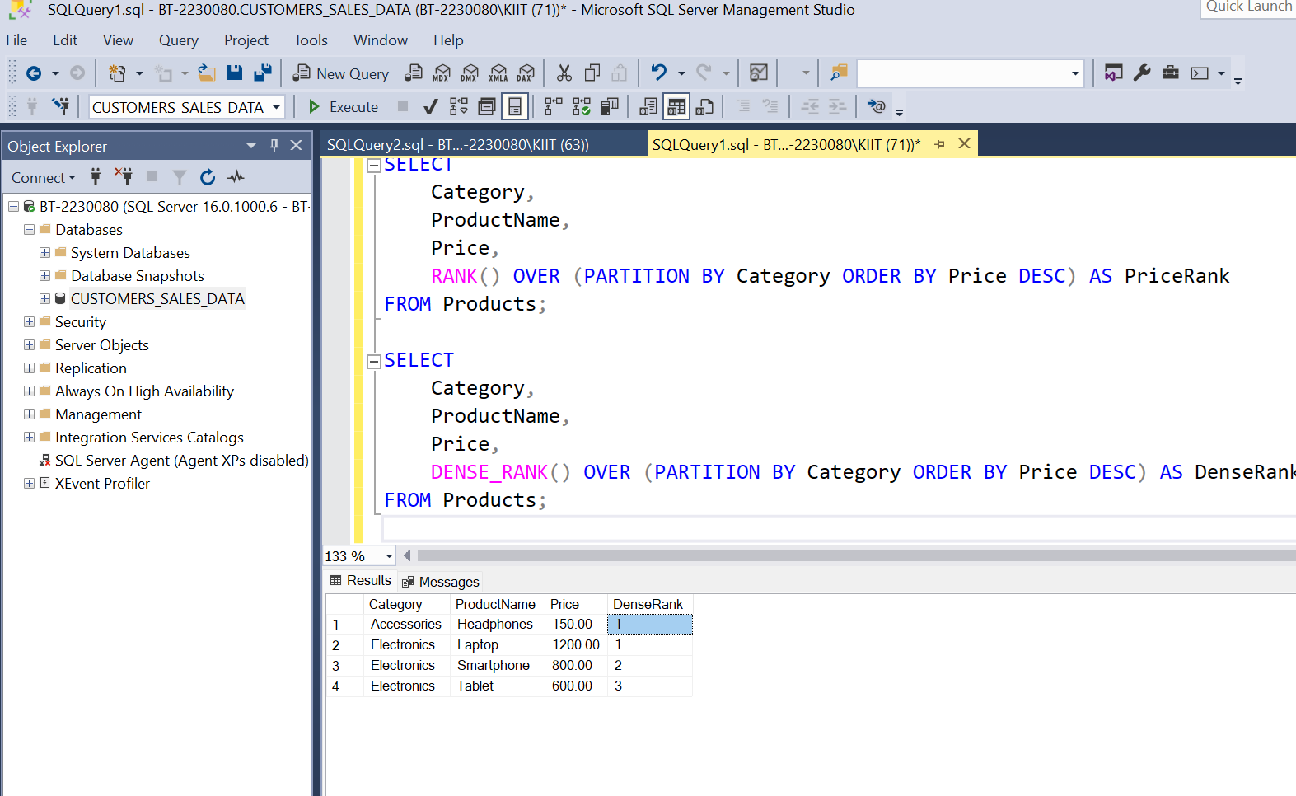

**INDEXING**

BEFORE INDEXING

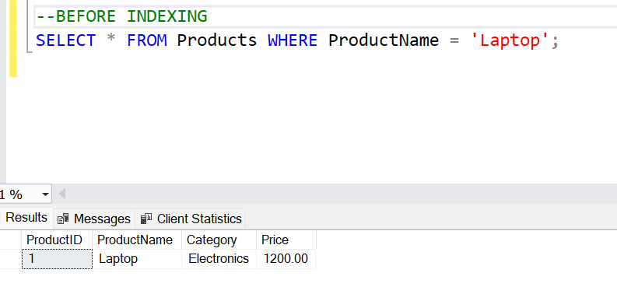

Exection time is negligible as the number of entries are minimal and limited

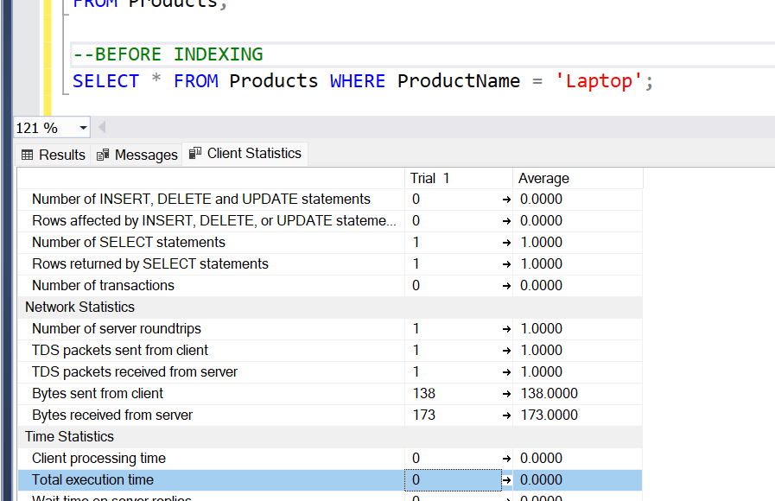

After Non- clustered Indexing :

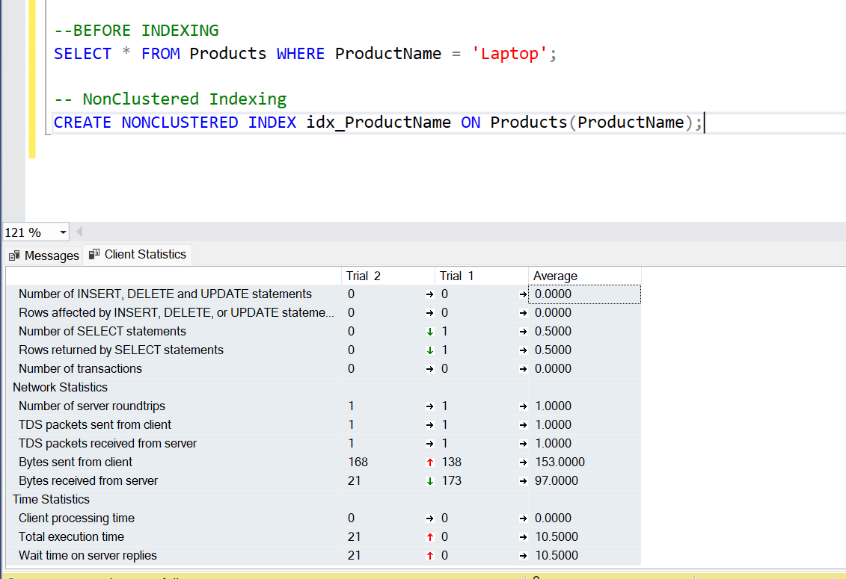

clustered Indexing :

Since only one clustered indexing is possible in a table and most have a default clustered indexing on primary key , hence showsb error while creating another clustered index.

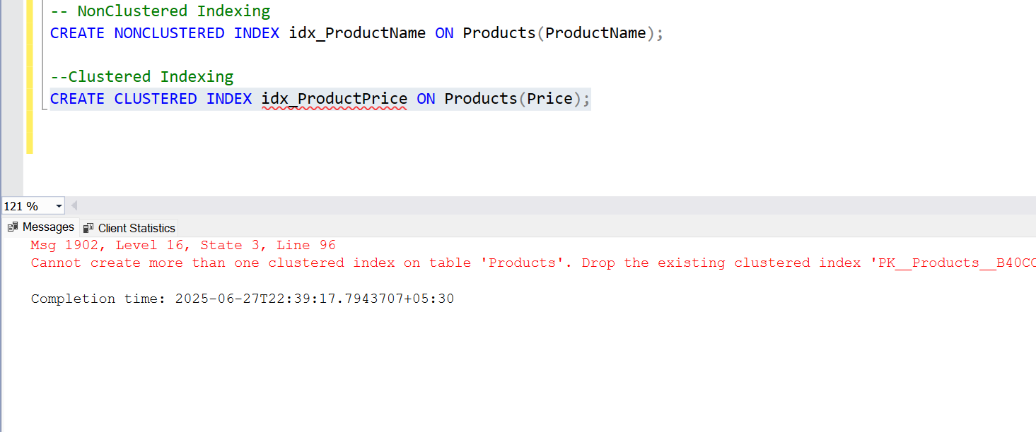

Composite Indexing:

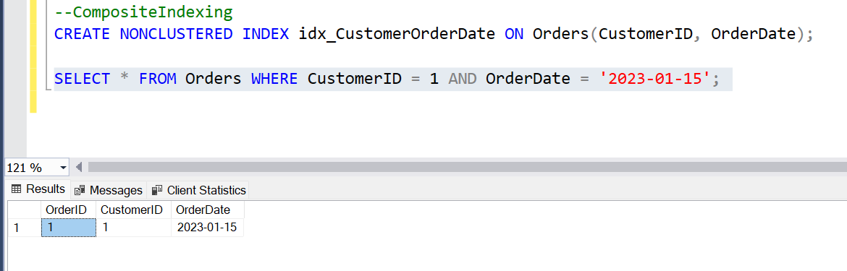

Exection statistics :

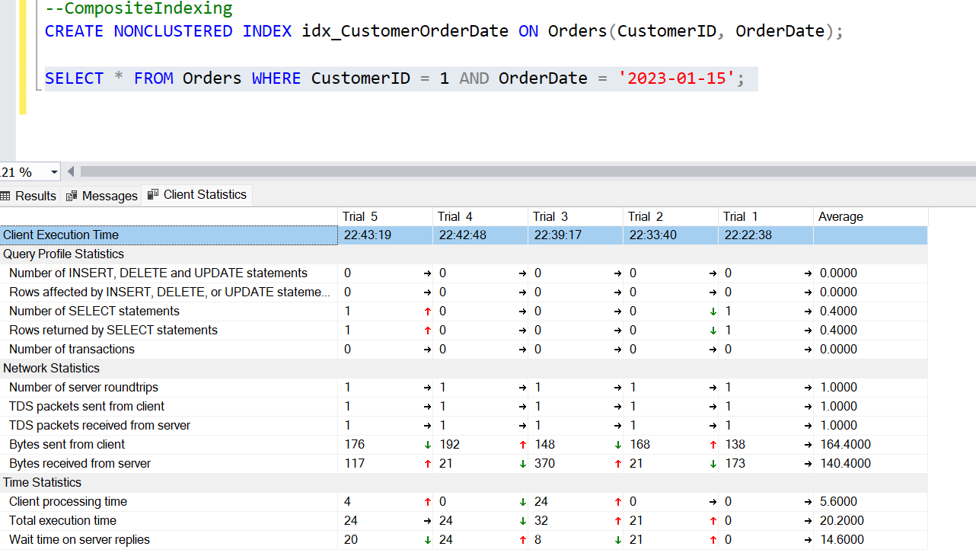

A composite non-clustered index was created on Orders(CustomerID, OrderDate) to improve query performance

**Before indexing**, queries had higher wait times (Trial 3: **32 ms** total execution).

**After indexing**, wait time dropped ( Trial 5: **24 ms total**, **20 ms server wait**).

Average execution time across trials was **20.2 ms**, with consistent **1 server roundtrip** and **1 row returned**.

This confirms that the index allowed SQL Server to quickly locate results, improving performance without changing the query logic.